Note: AI Usage documented in “AI-Usage.md”. This file will be uploaded as an “extra task”
Reader´s Log made by Simon Köper

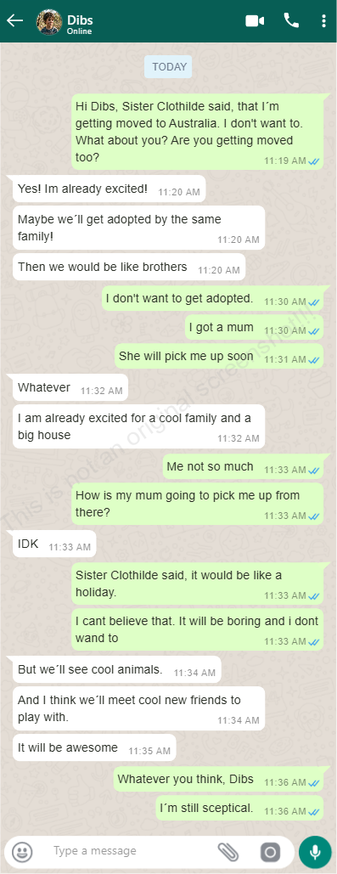
For This Chapter I´ve decided to create an online Chatroom about the situation of Calm and Dibs. It picks up from a conversation taken from the book and then got expanded.
The Chatroom was created using the provided site https://zeoob.com/generate-whatsapp-chat/

